Walmart Store Sales Project
Minor Project – Data Analysis Report

Q1: Total Sales by Year
Total sales across all stores for 2010, 2011, and 2012. Year 2011 recorded the highest total sales at $2.45 billion.
2010: $2,288,886,120.36 | 2011: $2,448,200,007.35 | 2012: $2,000,132,859.35
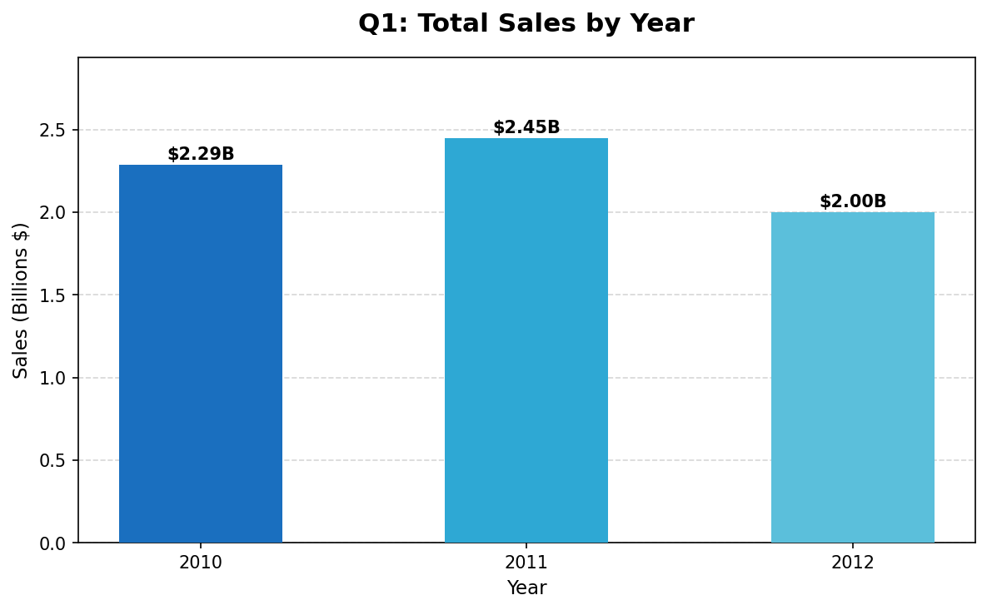

Q2: Maximum Customer Price Index (CPI) by Quarter
The CPI increased progressively across all four quarters, with Q4 recording the highest value of 227.23.
Q1: 225.11 | Q2: 225.59 | Q3: 226.76 | Q4: 227.23
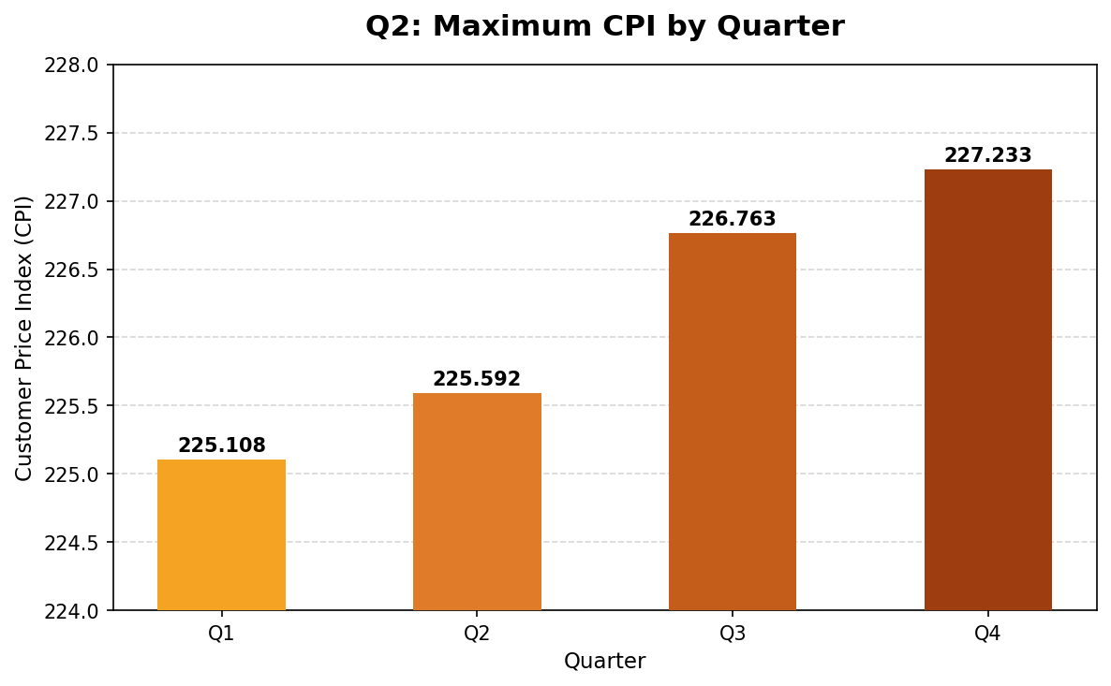

Q3: Maximum Sales by Quarter
Q4 had the highest maximum weekly sale at $3,818,686.45, significantly outperforming the other quarters.
Q1: $2,623,469.95 | Q2: $2,565,259.92 | Q3: $2,358,055.30 | Q4: $3,818,686.45
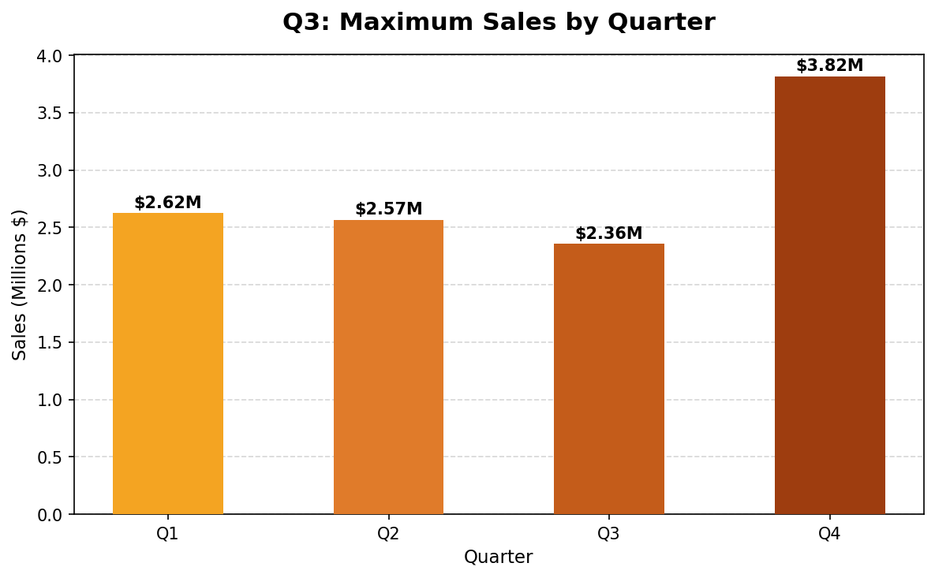

Q4: Correlation – Fuel Price vs CPI
Correlation Coefficient: -0.170642 (Weak Negative Correlation)
There is a weak negative relationship between fuel price and the consumer price index, suggesting that as fuel prices rise, CPI tends to decrease slightly.
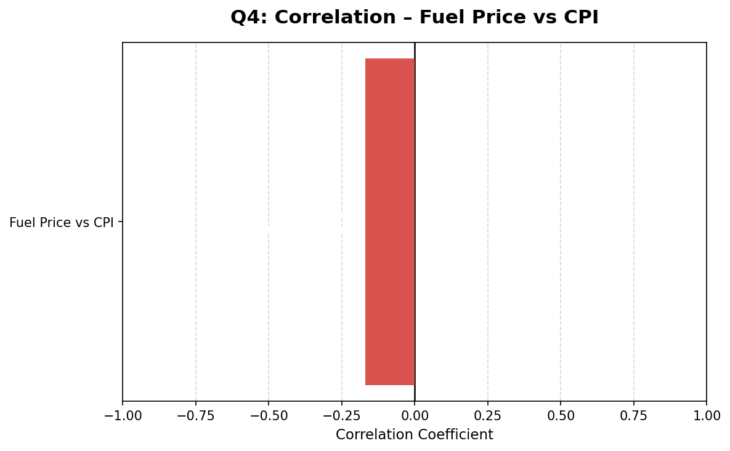

Q5: Minimum and Maximum Sales Year
Minimum Sales Year: 2012 ($2,000,132,859.35) | Maximum Sales Year: 2011 ($2,448,200,007.35)
The difference between the best and worst year is approximately $448 million.
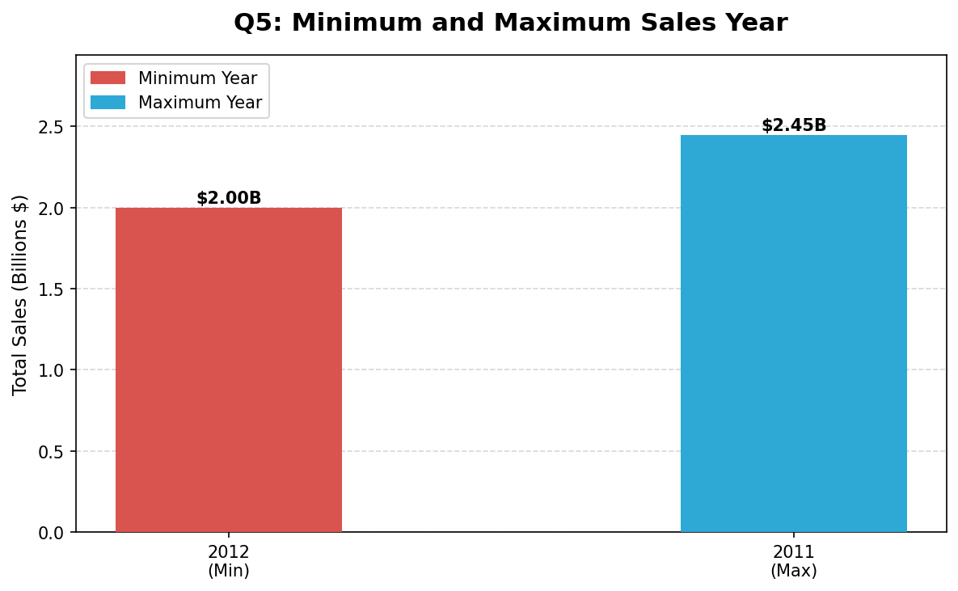

Q6: Standard Deviation of Fuel Price
Standard Deviation: σ = 0.459020
This indicates a moderate spread in fuel prices across the dataset period. The normal distribution curve visualizes how prices were distributed around the mean.
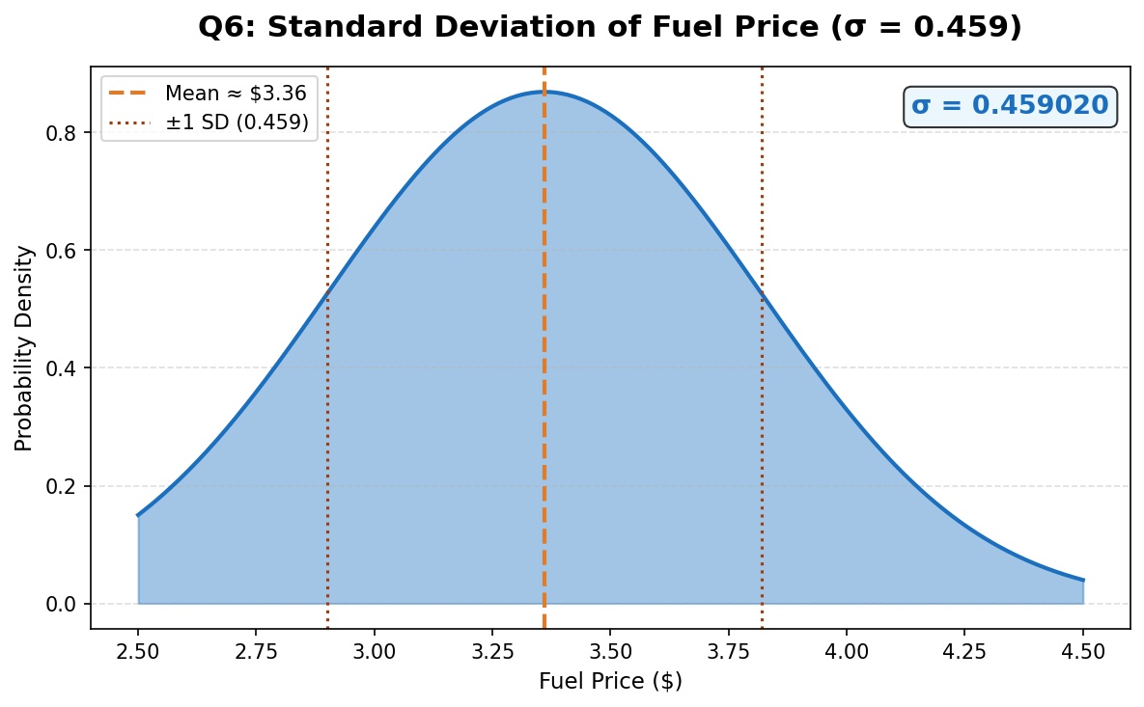

Q7: Correlation – Temperature vs CPI
Correlation Coefficient: 0.176888 (Weak Positive Correlation)
A very weak positive relationship exists between temperature and CPI, meaning higher temperatures are marginally associated with slightly higher consumer prices.
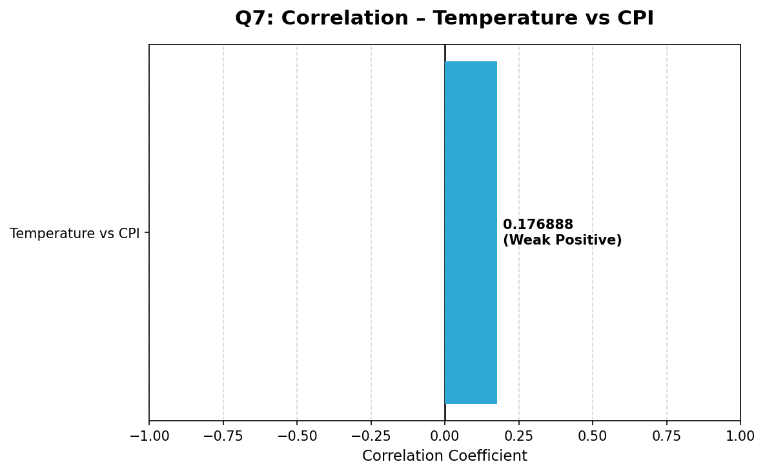

Q8: Correlation – Weekly Sales vs Temperature
Correlation Coefficient: -0.063810 (Very Weak Negative Relationship)
Temperature has virtually no meaningful impact on weekly sales. The correlation is negligible.
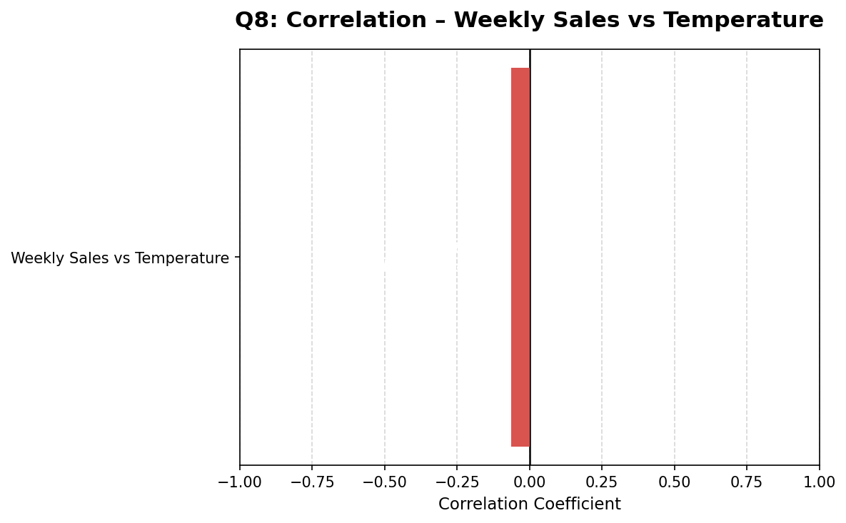

Q9: Correlation – Weekly Sales vs Unemployment Rate
Correlation Coefficient: -0.106176 (Weak Negative Relationship)
There is a slight tendency for weekly sales to decrease as unemployment rises, but the relationship is weak.
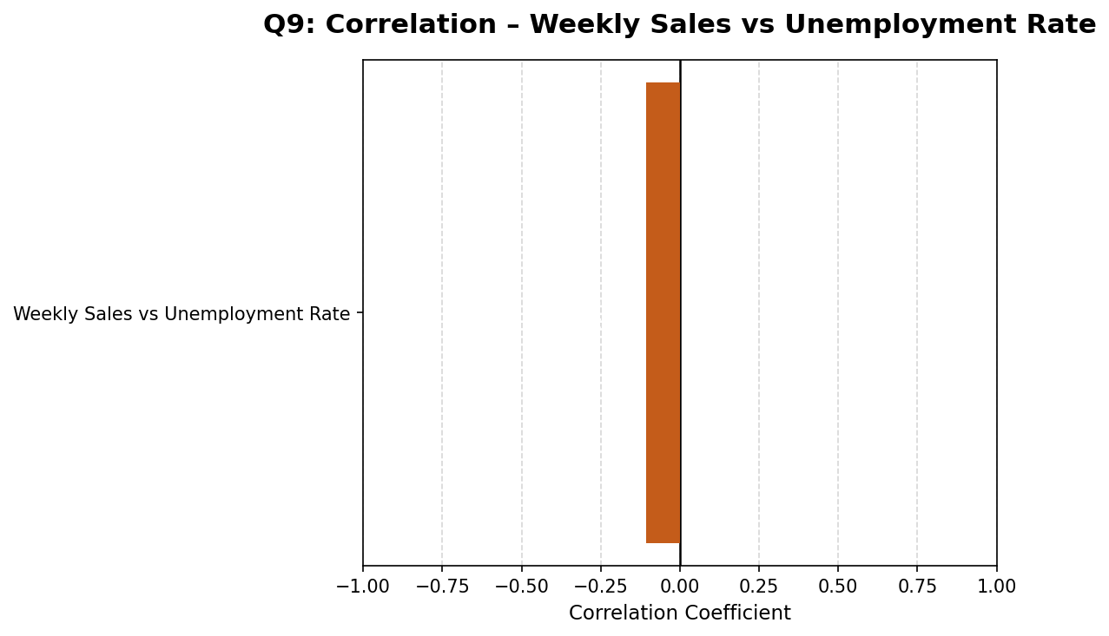

Q10: Dashboard – Complete Overview
A combined view of all key metrics: total sales by year, maximum sales per quarter, CPI trend, and all correlation summaries in one dashboard.
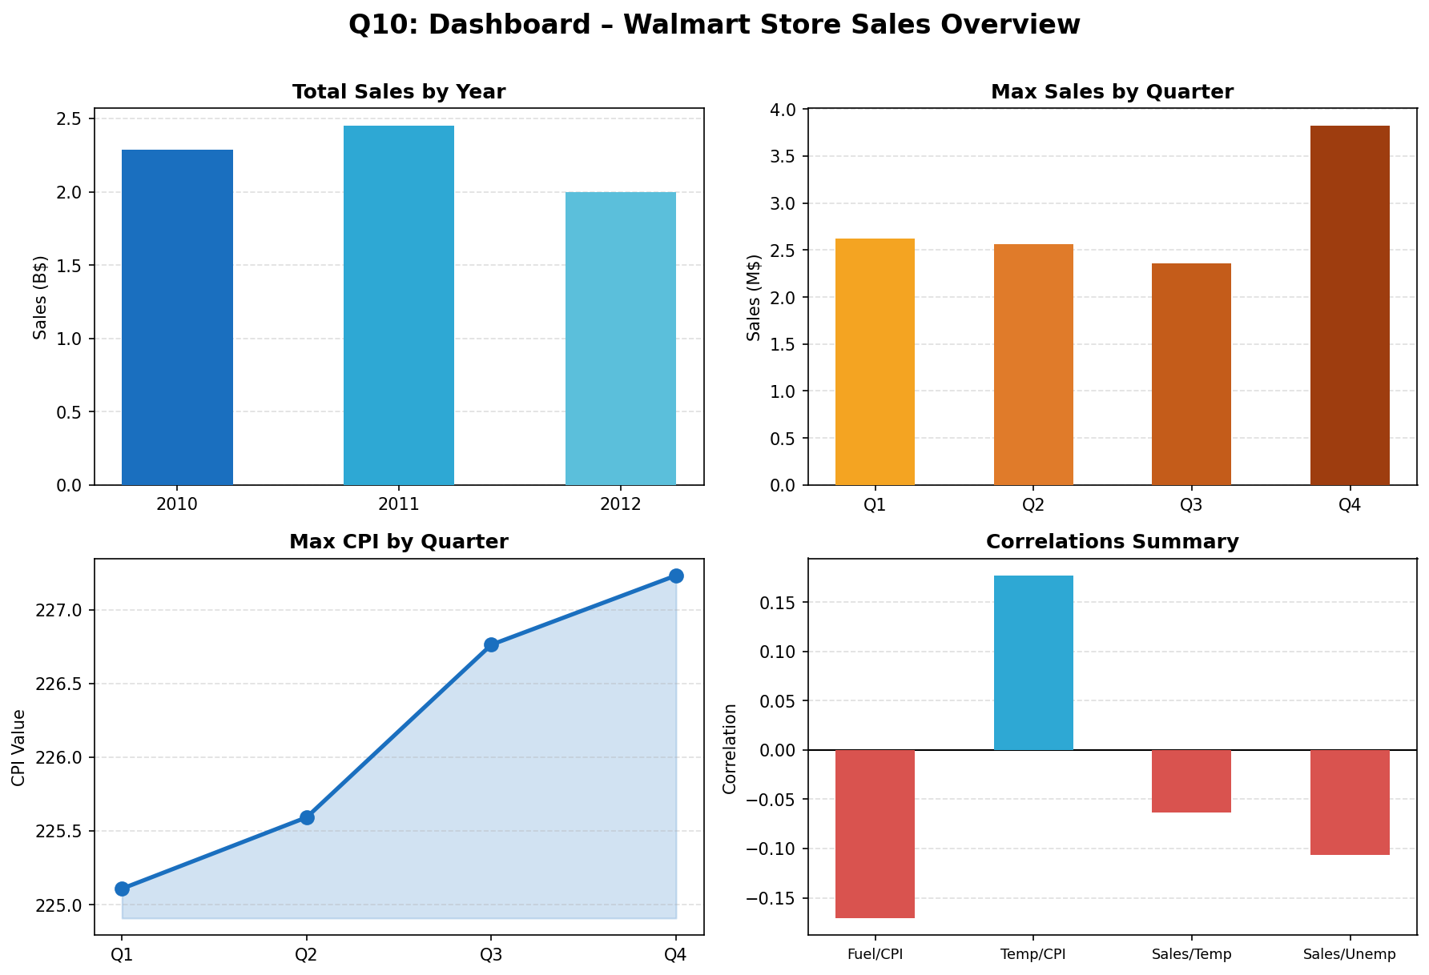

Conclusion
The Walmart sales analysis reveals several important insights:
• 2011 recorded the highest total annual sales ($2.45B), while 2012 had the lowest ($2.00B).
• Q4 consistently shows the highest maximum weekly sales, likely driven by holiday shopping.
• CPI increased steadily across all four quarters of the year.
• Fuel price and CPI have a weak negative correlation (-0.171).
• Weekly sales show very weak negative relationships with both temperature (-0.064) and unemployment rate (-0.106).
• These weak correlations suggest that sales at Walmart are relatively resilient to macroeconomic variables.

